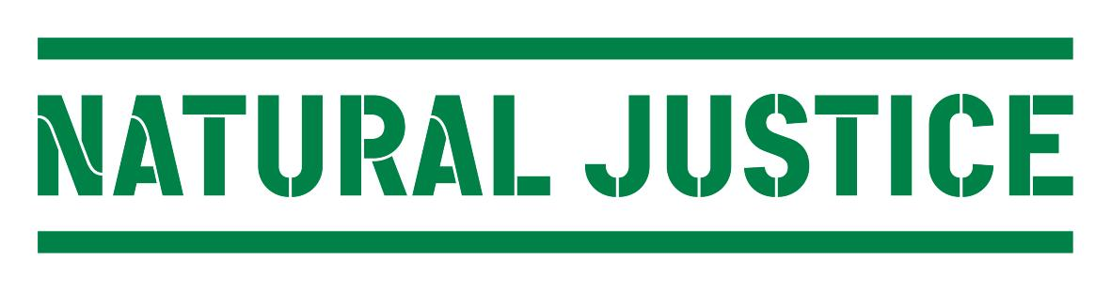
CONCEPT NOTE ON BIOCULTURAL COMMUNITY PROTOCOLS
____________________________________________________________________
What are bio-cultural community protocols?
- Bio-cultural community protocols (“community protocols”) are instruments that facilitate culturally rooted, participatory decision-making processes within communities with the aim of asserting rights over their communally managed lands and traditional knowledge.

- Community protocols are based on communities’ customary norms, values, and laws and set out clear terms and conditions to governments and the private, research, and non-profit sectors for engaging with communities and accessing their local resources.

- Community protocols facilitate conservation and sustainable use of biodiversity by ensuring that decisions regarding communally managed resources rest firmly with the communities who have served as stewards of these resources over many generations.

How might a community protocol be developed?
Developing a community protocol is an inclusive process that enables local participation and ownership, involves accessible approaches and resources, is reflective, constructive and representative of multiple voices, and leads to a visible influence on decision-making. The use of innovative participatory approaches and tools empowers communities not only to take ownership over existing legal and policy frameworks and processes such as protection of traditional knowledge and folklore, access and benefit sharing, REDD, protected areas, and payment for ecosystem services, but also to enable bottom-up law-making and the realization of their right to self-determination.
As such, community protocols are flexible instruments and each will be unique and tailored to the local context. Communities should focus on the types on information that would be most appropriate to include and how they want to document and communicate them. Examples for communication mediums include written documents, videos, photographs, maps, cultural performances, community radio or television programmes and so on. Communities may wish to produce multiple versions of their documented protocols for different purposes. For example, a community may wish to hold a cultural performance and radio series for itself, compile a written document with maps and photographs for the government and private sector, and produce a short film or slideshow to raise public awareness.

Every community protocol is distinct due to the unique biological and cultural diversity of the people that develop them. However, they tend to contain a variety of issues and themes, including details about:
• A definition of the group and its leadership and decision-making processes;
• Community-based natural resource management systems, knowledge, innovations, and practices (i.e. in situ conservation and sustainable use) of indigenous flora and fauna, and details of those natural resources;
• Ways of life, including the links between culture, spirituality, and customary laws and values;
• Interactions with other communities regarding the management of natural resources and sharing of traditional knowledge, innovations, and practices;
• Procedures relating to free, prior and informed consent to any intended activities on their territories;
• Local challenges and how they are addressing or would like to address them;
• Aspirations and endogenous development plans;
• Rights, responsibilities, and duties according to customary, national, and international law; and
• Calls to various stakeholders to engage in constructive dialogue with them according to their respective rights, responsibilities, and duties.

The development of a community protocol is first and foremost a community process, but can invite external support as required for developing local capacities in documentation techniques, legal empowerment, and facilitating meetings with government, among others. Once developed, protocols require strong and continued support from community infrastructure, including its local institutions, CBOs, NGOs, and lawyers, in order to enact long-term social and political change.

Are community protocols a new idea?

Indigenous peoples and local communities have long-standing customary norms, values, and laws that establish clear rules for how to manage and share their resources and knowledge. Community protocols are an innovation to the extent that they are designed to help communities document and articulate these customary norms, values, and laws in a manner that ensures their recognition under emerging national and international laws.
What is the legal relevance of community protocols?
Community protocols are locally developed legal instruments that seek to address the lack of community involvement in the development and implementation of laws and policies that affect their communally managed lands, resources, and ways of life.
For indigenous peoples and local communities, the ecosystem is often the greatest and most important goods and services provider, ensuring food, shelter, and health care in situations where it is not possible for governments to provide them. The ecosystem also has many complex social, cultural, and spiritual values that are inextricably linked with communities’ ways of life. The loss of community control over ecosystems, including biological and genetic diversity and associated traditional knowledge, results in the loss of livelihoods, the erosion of cultures and ways of life, and the undermining of the environmental, food, and health security of society at large.
The history of communally managed resources can be traced back for thousands of years. However, the history of community rights relating to biodiversity began with the movement for the rights of indigenous peoples and farmers. This has resulted in soft law such as the International Labor Organization’s Indigenous and Tribal Peoples Convention (ILO 169) 1989 and the United Nations Declaration on the Rights of Indigenous Peoples 2007. It has also influenced treaty law such as the United Nations Convention on Biological Diversity (CBD) 1993. In addition, the struggle to clearly affirm the rights of indigenous peoples, farmers, and other local communities over their lands, resources, and cultures is currently being played out in several international negotiations, including the Protocol on Access and Benefit Sharing under the CBD, the Programme on Reducing Emissions from Deforestation and Forest Degradation in Developing Countries (REDD) under the United Nations Framework Convention on Climate Change, the United Nations Forum on Forests, and the World Intellectual Property Organization’s Inter-Governmental Committee on Intellectual Property and Genetic Resources, Traditional Knowledge and Folklore. There has also been a significant shift in domestic law-making over the last decade with increasing de jure recognition of the rights of communities over their lands, resources, and ways of life.
However, very few of these legal provisions have translated into the de facto recognition of community rights. In both the international and domestic arenas, the State has taken on the role of parens patriae, making decisions on behalf of communities on the pretext that communities are unorganized and do not have effective decision-making structures.
States have also marginalized existing community systems of organization in the name of national interest and economic development. With the growing strength of the movements for the rights of indigenous peoples, farmers, and other local communities, States are now expressing a willingness to recognize community rights in theory, but argue that when it comes to communal resources, the notion of ‘community’ is too ambiguous and does not represent a distinct, homogenous unit that they can realistically engage with. While this may be true to an extent, communities have responded by asserting that while no society is homogenous, all societies have processes for regulating the use and sharing of resources, and that communities who are most dependent on these resources are best placed to make decisions regarding them. Indigenous peoples, farmers, and local communities in different parts of the world are now advocating for the use of community protocols as a way to clearly articulate their customary laws, values, and norms and existing rights relating to the use of community resources that States would then need to recognize, uphold, and enforce.
How are community protocols being recognized at the local, national, and international levels?

Community protocols are being developed most actively in the context of the CBD. The three objectives of the CBD are a) conservation, b) sustainable use of biodiversity, and c) the fair and equitable sharing of benefits arising from the use of biodiversity and biodiversity-related knowledge.
At the local level, some indigenous, agrarian, and pastoralist communities in South Africa, Kenya, India, Malaysia, and Panama, among others, have begun to develop community protocols that affirm their rights to community control and decision-making processes relating to their lands, resources, and ways of life. Last year, a formal resolution was passed at a meeting of over 60 African community representatives that advocates for the use of community protocols as a way for African governments to recognize community rights. At a recent meeting in Khaba, Rajasthan, the representatives of the LIFE Network-India (a national network of pastoralists’ and livestock keepers’ organizations) also affirmed community protocols as a way to secure livestock keepers’ rights in India.

The main ongoing negotiations under the CBD relate to access and benefit sharing. At the national level, African governments have advocated community protocols as a means to affirm community rights in their negotiations towards the International Regime on Access and Benefit Sharing. Community protocols have also received support from other countries involved in the negotiations including some Asian and Latin American countries and the European Union. If the final draft adopted at the upcoming CBD Conference of Parties in October still contains reference to “community protocols”, then the 194 CBD Parties will be legally bound to enact national laws that recognize communities’ protocols. This will be a significant step towards the widespread international and national recognition of community protocols as legal instruments for community management of their lands, resources, and ways of life.

